**评价须知（2009-2-15开始实行）：**

请您根据本次交易，给予真实、客观、仔细地评价。您的评价将是其他会员的参考，也将影响卖家的信用。

**累积信用计分规则：**中评不计分，但会影响卖家的好评率，请慎重给予。每个自然月中，相同买家和卖家之间的信用评价计分不超过6分。评价后30天内，您有一次机会删除给对方的中评或差评，或者修改成好评。

**动态店铺评分计分规则：**店铺评分是匿名的。每个自然月中，相同买家和卖家之间的店铺评分计分次数不超过3次。店铺评分成功后无法修改。

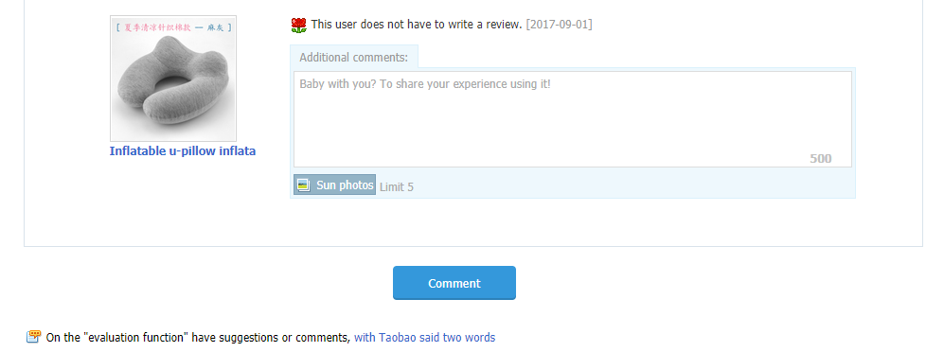

**Important:**Before you can post a review, you need to have an Amazon.com account that has successfully been charged for the purchase of a physical or digital item. Free digital downloads don't qualify. You don't need to have purchased the product you're reviewing. There's a 48-hour waiting period after your first physical order has been completely shipped, or your digital item has been purchased, before you'll be able to submit your review. If you've purchased a digital gift for someone else, the 48-hour waiting period doesn't begin until the gift has been redeemed.

<https://www.amazon.com/gp/help/customer/display.html?nodeId=201145120>

We've worked over the years to make our millions of customer reviews as useful as possible – we’ve added features like Amazon Verified Purchase, helpful votes, and review comments in the pursuit of a system that’s open and flexible and yet structured and helpful for anyone who wants to learn more from other customers about anything we sell.

Over time we've also built mechanisms, both manual and automated, that remove reviews which violate our guidelines. We recently improved our detection of promotional reviews which resulted in the removal of reviews, both new and old. While our enforcement has improved, our [Customer Review Creation Guidelines](https://www.amazon.com/gp/help/customer/display.html?nodeId=201602680) have not changed. We hope to keep improving our approach over time and we welcome [feedback](https://www.amazon.com/gp/html-forms-controller/ReviewsGuidelinesFeedback) from customers and reviewers alike on how to keep making reviews more valuable to Amazon shoppers.

Customer Reviews are meant to give customers genuine product feedback from fellow shoppers. Our goal is to capture all the energy and enthusiasm (both favorable and critical) that customers have about a product while avoiding use of reviews to outright advertise, promote and especially mislead. We have a zero tolerance policy for any review designed to mislead or manipulate customers. Customer Reviews help customers learn more about the product or genre, hear the reasons behind your star rating, and ultimately decide if this is the right product for them or not.

Authors and artists can add a unique perspective and we very much welcome their customer reviews. While we encourage reviewers to share their enthusiasm and experience, there can be a fine line between that and the use of customer reviews as product promotion. We don't allow anyone to write customer reviews as a form of promotion and if we find evidence that a customer was paid for a review, we'll remove it. If you have a direct or indirect financial interest in a product, or perceived to have a close personal relationship with its author or artist, we'll likely remove your review. We don't allow authors to submit customer reviews on their own books even when they disclose their identity.

Below each review, you’ll find a question that asks "Was this review helpful to you?" – if you answer "no," you can let us know why the review is inappropriate. We'll examine the review and take action if necessary.

To help illustrate, here are a few examples of reviews that we don't allow:

* A product manufacturer posts a review of their own product, posing as an unbiased shopper
* A shopper, unhappy with her purchase, posts multiple negative reviews for the same product
* A customer posts a review in exchange for $5
* A customer posts a review of a game, in exchange for bonus in-game credits
* A family member of the product creator posts a five-star customer review to help boost sales
* A shopper posts a review of the product, after being promised a refund in exchange
* A seller posts negative reviews on his competitor's product
* An artist posts a positive review on a peer's album in exchange for receiving a positive review from them

If you think we got it wrong and removed a customer review that we shouldn’t have, please e-mail **review-appeals@amazon.com** and we will take another look.

**Note:**The best place for authors (or publishers) to communicate with their readers is in the Book description, Editorial Reviews and From the Author sections. To learn more about taking advantage of these features, visit [Author Central](https://authorcentral.amazon.com/" \t "_blank).

https://www.amazon.com/gp/help/customer/display.html/ref=hp\_left\_v4\_sib?ie=UTF8&nodeId=201967050

We take the integrity of our reviews platform very seriously. If we determine that you have attempted to manipulate reviews or violated our guidelines in any other manner, we may immediately suspend or terminate your Amazon privileges, remove reviews, and delist related products. In addition, if we determine that an Amazon account has been used to engage in review manipulation, remittances and payments may be withheld or forfeited. Misconduct may also violate state and federal laws, including the Federal Trade Commission Act, and can lead to legal action and civil and criminal penalties.

We pursue lawsuits for reviews manipulation against dishonest sellers and manufacturers who attempt to purchase fraudulent reviews and the parties who provide and post those reviews. These lawsuits have produced monetary judgments exceeding the annual revenue for such sellers and data allowing us to take additional enforcement actions against others. We suspend and ban the accounts of others who engage in review abuse or otherwise violate our guidelines. We will continue to remove reviews that violate our policies and pursue the sellers and manufacturers who create the demand for fraudulent reviews and the individuals and organizations who supply fraudulent reviews through all available means.

We encourage anyone who suspects that review manipulation is taking place or that our guidelines are being violated in any other manner to notify us. We will investigate the concern thoroughly and take any appropriate actions.